Hand Sanitizer and Disinfectant

Published: 18 Jun 20 2:00pm

As the novel coronavirus continues to spread, some countries are still undergoing various forms of lockdown. At the same time, a handful of countries including Spain, Iran, Italy, Denmark, Israel, Germany, and South Korea that previously imposed restrictions are beginning to lift the lockdown measures. Many countries around the world are reopening. Essentially all restrictions including workplaces, schools, public locations, tourism activities and global transits will be expected to lift in stages.

Many travelers will be moving around with hand sanitizer and surface disinfectant whenever in public and high-density areas sort off lifts, railing walkway, train station, railway station, schools, restaurants, hotels, malls, recreation parks, canteens, gym rooms, etc.
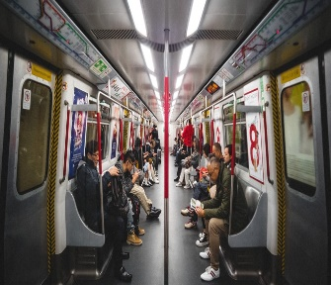
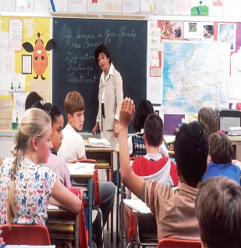
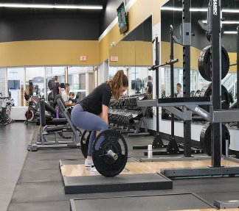
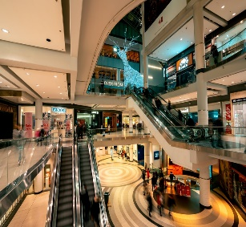

Penchem Hand Sanitizers are designed with 75-80% Alcohol according to World Health Organization recommended formulation. Our surface Sanitizers or Disinfectants contain of Hydrogen Peroxide and Benzalkonium Chloride Active Ingredients for effective elimination of viruses and bacteria. This is disinfectants are designed in water-based and available in small packaging to ease the flight travelers. As Penchem is playing role of social corporate responsibility to our society with charity works during Cov19, Penchem also provide handy free samples for any minimum purchase to our customers as a return to the society. We care for you.

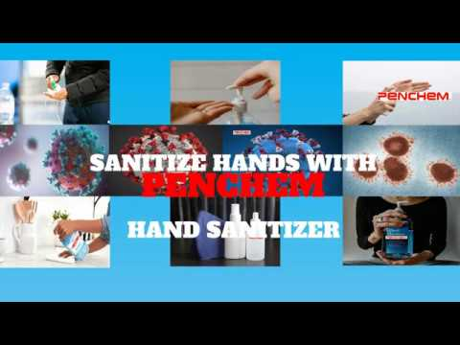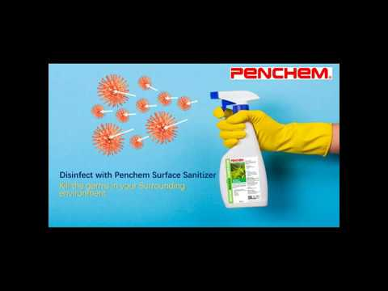
‘Nowadays, we travel around with a Handy Penchem Water-based Disinfectant or Hand Sanitizer’
Click to play the videos

For any enquiry or order, please feel free to contact us
Penchem Technologies Sdn Bhd
Email: enquiry@penchem.com
Tel: +604-501 5976

